|  |  |
| --- | --- |
|  | Student Name _______________________    **Eastern Goldfields College**  Mathematics Applications 2018  Test 3 – Calculator Free1 |
| **Time allowed: 22 minutes** | **Total Marks: 22 marks** |

**No calculator or notes permitted for this section.**

***Show all working where appropriate to obtain full marks.***

**Question 1**  **(5 marks: 1, 1, 2, 1)**

**     **

Using the matrices given above, calculate the following. Where the operation is not possible, provide an explanation.

|  |  |
| --- | --- |
| a) E + A | b) DC |
| c) A2 | d) 3B |

**Question 2** **(1 mark)**

Determine the price to earnings ratio for a share with a price of $6.00 and dividends in the last twelve months totalling 75 cents per share.

**Question 3 (4 marks: 2, 2)**

The figures below are similar.

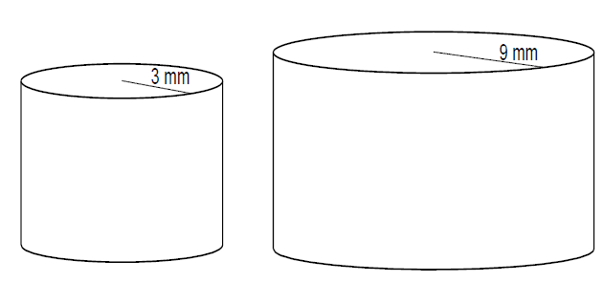a) The surface area of the smaller cylinder is 25 mm2. What is the surface area of the larger cylinder?

b) The prisms below are similar. The volume of the larger prism is 800 m3. What is the

volume of the smaller prism?

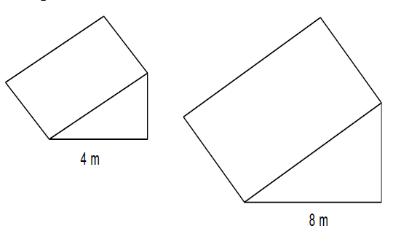

**Question 4 [4 marks: 2, 2]**

Charlene was calculating with matrices. She got the following answers incorrect. Explain what she did wrong and write the correct solution.

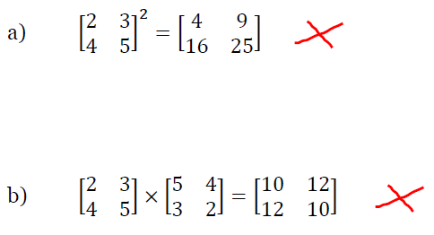



**Question 5 (8 marks: 4, 4)**

For each of the following similar triangles**:**

1. Name the similar triangles
2. Explain why they are similar
3. Determine the value of *x*

.

1. 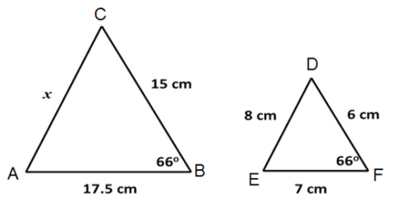

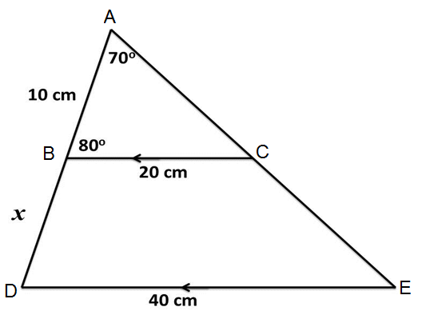



|  |  |  |
| --- | --- | --- |
|  | Student Name _______________________    **Eastern Goldfields College**  Mathematics Applications 2018  Test 3 – Calculator Assumed1 | |
| **Time allowed: 25 minutes** | **Calculator and Notes permitted** | **Total Marks: 24** |

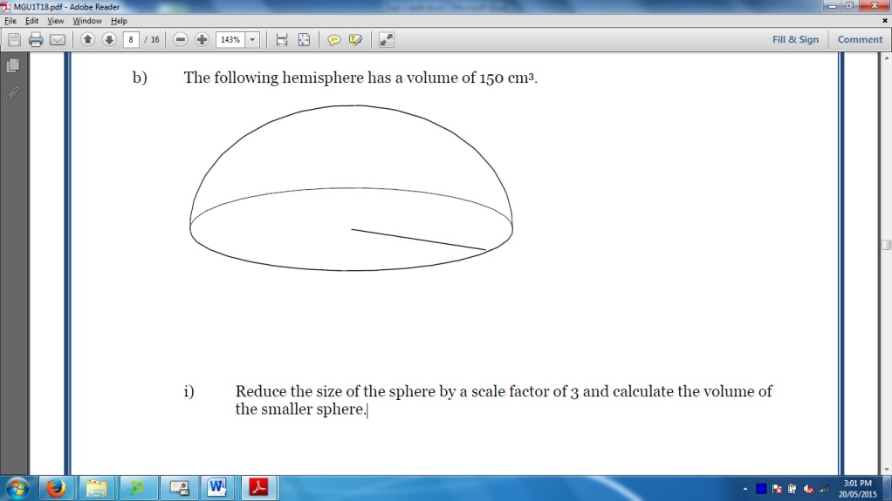**Question 7 (2 marks)**

The following hemisphere has a volume of 150 cm3. Reduce the size of the hemisphere by a scale factor of 3 and calculate the volume of the smaller hemisphere.

**Question 8 (6 marks: 2, 2, 2)**

John wants to see which of the two banks in his portfolio of shares the better performer is, and he decides to use the P/E ratio to compare the two banks.

$$P/Eratio=\frac{Market price per share}{Annual earnings per share}$$

AAA Bank’s shares are currently $33.65 while ZZZ Bank’s shares are currently $32.055.

AAA Bank has annual earnings of 207.5 cents per share.

ZZZ Bank has annual earnings of 223.1 cents per share.

1. Calculate the *P/E* ratio for each bank

b) Make a recommendation as to which bank John should buy more of, if the P/E ratio was the only indicator to be used. Justify your recommendation.

c) Dividends from both banks are paid twice a year and in the last year AAA Bank gave dividends at 82c and 84c per share. What percentage of its annual earnings does AAA Bank distribute to shareholders?

**Question 9 (6 marks: 3, 3)**

|  |  |
| --- | --- |
| Status | Fortnightly Payment |
| Single less than 18 years living at home | $226.80 |
| Single less than 18 years not living at home | $414.40 |
| Single older than 18 years living at home | $272.80 |
| Single older than 18 years not living at home | $414.40 |
| Single with children | $542.90 |

Youth Allowance gives financial aid to people aged 16 to 24 studying full time, training, looking for work or sick. Payment rates are:

Youth Allowance students can earn an *income* but this reduces the fortnightly payment according to the following table:

|  |  |
| --- | --- |
| Income / fortnight | Reduction in fortnightly payments |
| $414 and below | Nil |
| $415 - $498 | 50 c for every dollar over $414 |
| $499 and over | $42 plus 60 c for every dollar over $498 |

Gerry is single, 17 years old and lives at home. He earns $10,000 p.a. on part-time jobs and is studying full time. Richard is 21 years old and does not live at home. He studies full-time and works part-time. His yearly income is $13,520.

Gerry and Richard receive $226.80 and $359.20 per fortnight respectively in youth allowance. Using the tables above, justify mathematically Gerry’s and Richard’s youth allowance payments.

**Question 10**  **(5 marks: 1, 1, 3)**

Two friends went on a trip overseas and brought back some unspent foreign currency which they need to exchange back to Australian dollars (AUD).

They have made a table showing the amounts of each currency they each have.

|  |  |  |
| --- | --- | --- |
|  | Bali (Indonesia) | Singapore |
| Kate | 190 000 IDR | 200 SGD |
| Guy | 175 000 IDR | 350 SGD |

The exchange rates when they convert their money are as follows:

10 000 IDR (Indonesian rupiah) = 0.9700 AUD

1 SGD (Singapore dollars) = 0.8666 AUD

1. How much in Australian dollars (to the nearest ten cents) will Kate get for her Indonesian rupiah (assuming she pays no commission fees)?

b) Justify why one Australian dollar is approximately 10 309 Indonesian Rupiah.

c) Who is left with the most money when they return to Australia? Justify your answer.

**Question 11 [5 marks: 1, 2, 2]**

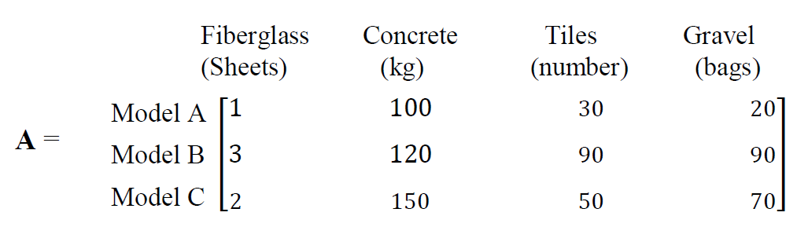Swimming’s Cool is a company which produces swimming pools. They have three different models of pool which they sell and each one requires a different amount of each of the following materials as shown in matrix **A** below.

a) Swimming’s Cool receives the following orders: 4 of Model A, 2 of Model B and 1 of Model C. Create matrix **B** to represent this information.

b) Use matrix methods to calculate the total amount of each material needed to fill the order.

c) The costs for each of the materials are as follows:

Fiberglass Concrete Tiles Gravel

($300/Sheet) ($50/kg)\ ($5 each) ($70/bag)

Calculate, **using matrix methods and showing full working**, the total cost of the order.

**End of Test**